FIL Project Management System

Use Case and analysis classes

Use case:

The users in this project management system will be :

1. Students
2. Faculty advisors.
3. Parterner.

4. Manager/Admin (this will be a student user or a faculty advisor)

The use case diagram is as follow:

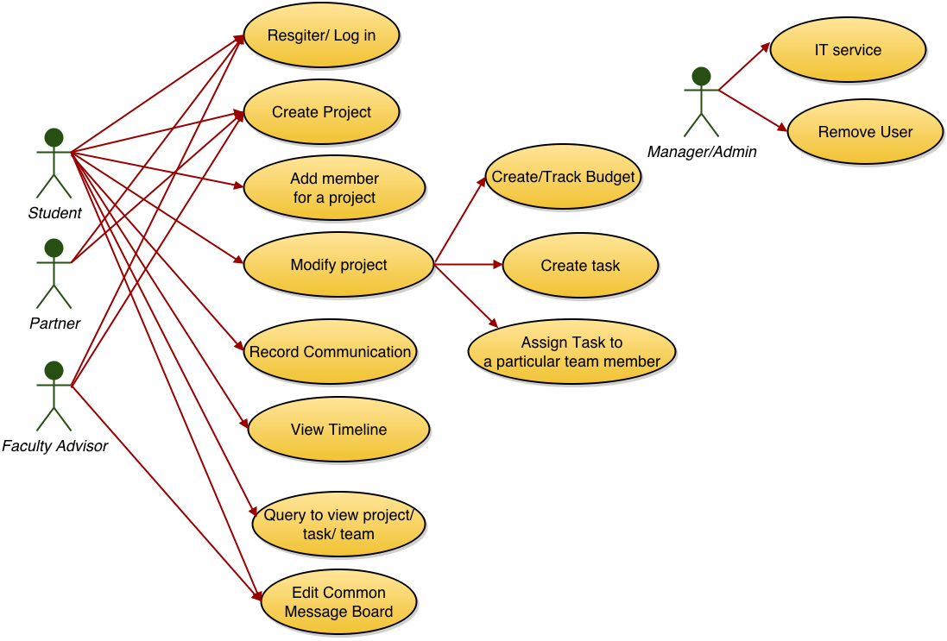

For the analysis class

* + Boundary classes
    - Register behavior
    - LogIn behavior
    - Create Project behavior
    - Add member for a project behavior
    - Modify project behavior
    - Record communication behavior
    - Create timeline behavior
    - Create budget behavior
    - Track budget behavior
    - Create task behavior
    - Assign task behavior
  + Control classes
    - User CRUD controller
    - Project CRUD controller
    - Communication CRUD controller
    - Task CRUD controller
    - Budget CRUD controller
    - Timeline generation/ display controller
    - Common message board display controller
  + Entity classes
    - User information
    - Faculty information
    - Student information
    - Partner information
    - Communication information
    - Project information
    - Task information
    - Budget information

The entity class diagram can be seen as follows:

